Name: ___________________________ Date: ____________ Period: ____________

Build the Trophic Levels

Objective: Make a trophic level pyramid by cutting and pasting organisms into a chart and answering questions about the trophic levels.

Procedure:
- Create a Pyramid Labeled with the following labels on the poster paper:
Producers
Primary Consumer
Secondary Consumer
Tertiary Consumer

- Use pictures of organism along with their names. Cut and paste the organisms into the trophic level where you believe they belong based upon prior knowledge. You may use your technology devices to assist you.

- If the producers are receiving 26,600 kcal of energy from the sun. How much energy is making its way up the pyramid? Between your trophic levels draw 3 food chains and indicate how much energy each organism is obtaining.

- You have one picture of each organism. Do some research and indicate how many of each species should be present at each trophic level. The numbers only need to be approximate.

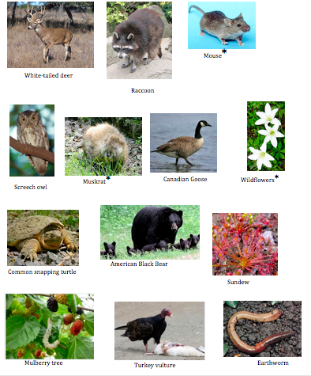

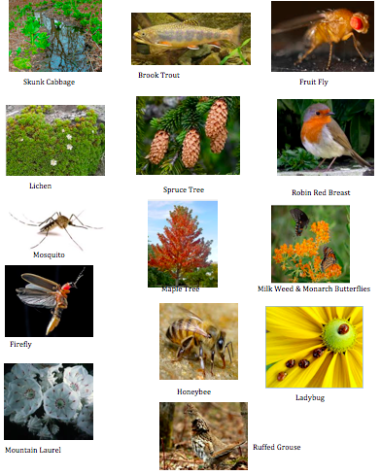

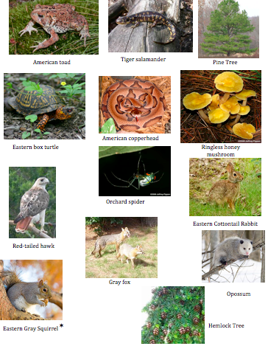

Name: __________________________________ Date: _____________ Period:______________

Basic Information Questions
- Which of the trophic levels has the most number of organisms? How many?
- Which of the trophic levels has the least number of organisms? How many?
- What are two examples of a secondary consumer?
- What are two examples of a primary consumer?
- What are three examples of a producer?
- What is the term for a model that shows the relationships between organisms, including the energy and number of each trophic level?
- What does autotroph mean?
- At which trophic level are autotrophs found?
- What do you think heterotroph mean?
- Which trophic levels are heterotrophs found at?
- Give an example of a primary herbivore.
- Give an example of a secondary omnivore.
- Give an example of a tertiary carnivore.
- Give an example of a tertiary decomposer.
- Give an examples of a scavenger.
Extension/Higher Order Questions
- What does the direction of an arrow in a food chain or food web indicate?
- Why can’t food chains go on forever? (8th, 9th, 10th level consumers)
- Choose a secondary consumer. Explain what you think would happen to the other organisms if disease were to kill off this secondary consumers.
- Some of the organisms have an asterisk * next to them this indicates a toxin being spread on them. What do you believe happens to the toxin as it moves from a lower trophic level to a higher trophic level?

